EXPERIMENT :6

**Demonstrate virtualization by Installing Type-2 Hypervisor in your device, create and configure VM image with a Host Operating system (Either Windows/Linux).**

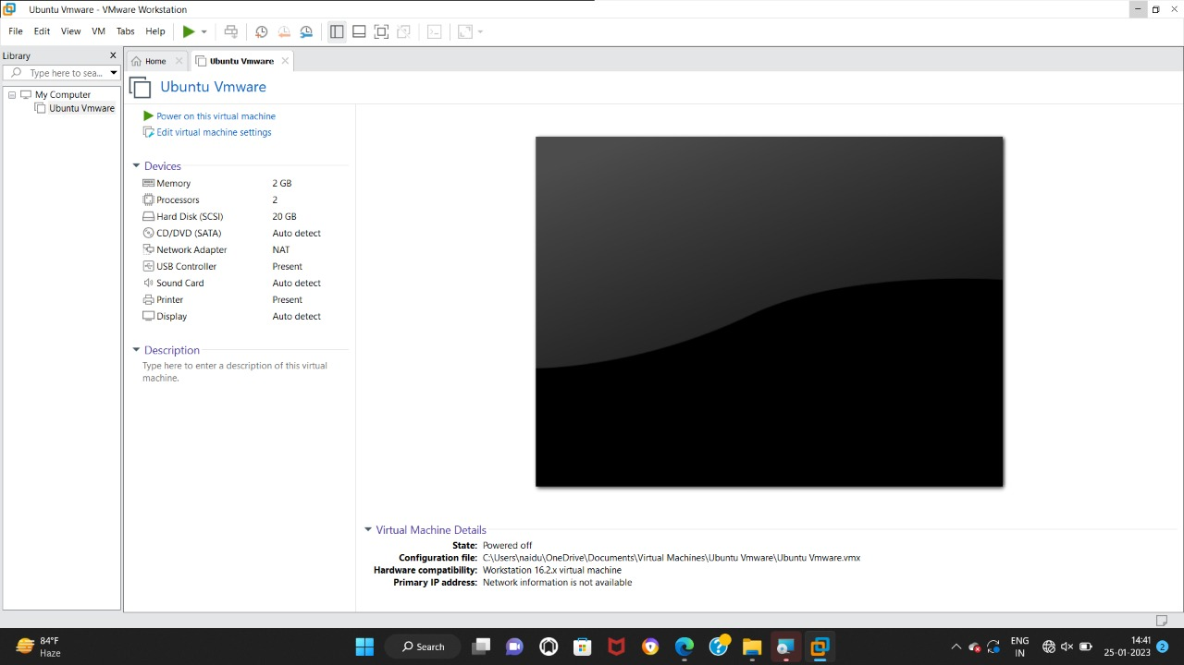

EXPERIMENT :7

**Create a Virtual Machine with 1 CPU, 2GB RAM and 15GB storage disk using a Type 2 Virtualization Software.**



EXPERIMENT :8

**Create a Virtual Hard Disk and allocate the storage using VM ware Workstation**

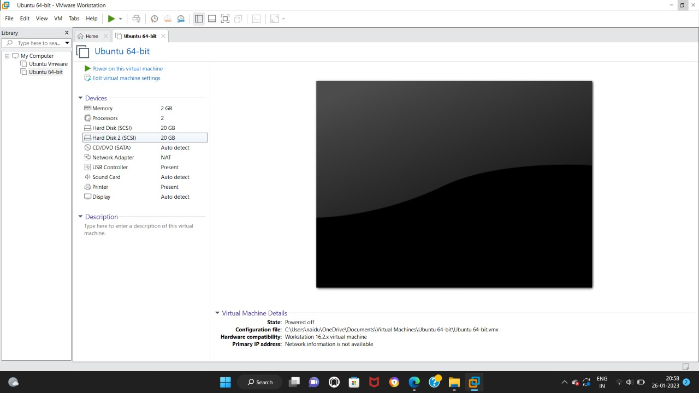

EXPERIMENT 9

**Create a Snapshot of a VM and Test it by loading the Previous Version/Cloned VM**

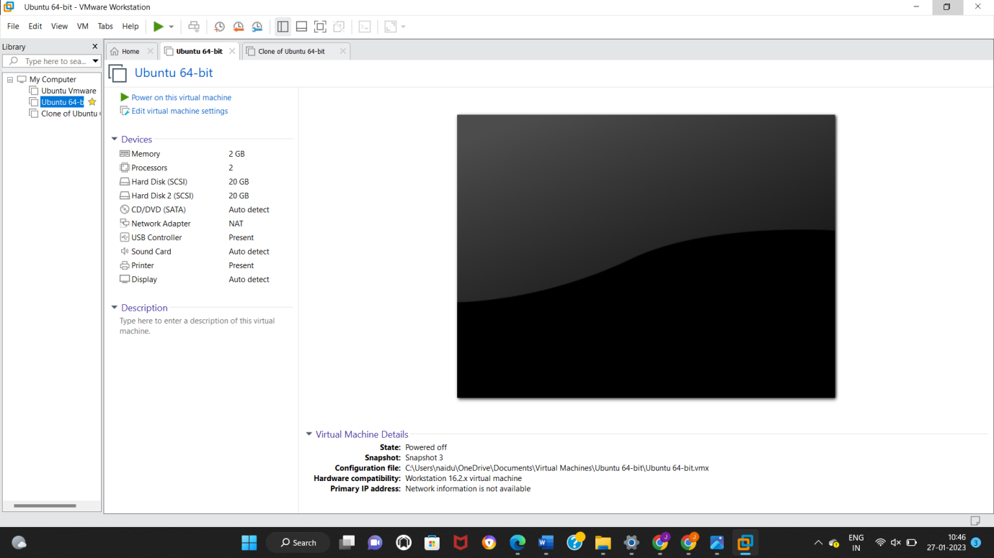

EXPERIMENT-10

**Create a Cloning of a VM and Test it by loading the Previous Version/Cloned VM**

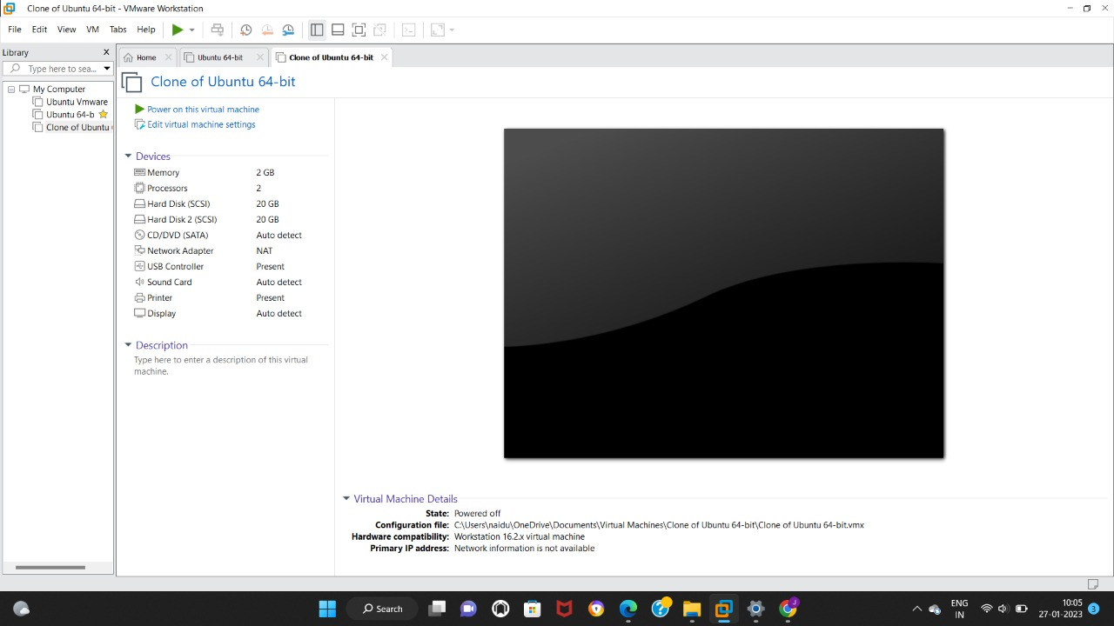

EXPERIMENT 11:

**Change Hardware compatibility of a VM (Either by clone/create new one) which is already created and configured.**

